**DATA ANALYTICS LAB**

**(AcademicYear: 2024-25) .Tech III Year – II Semester (R22)**

**DATA ANALYTICS LAB**

**Experiment 7 Date :**

**-------------------------------------------------------------------------------------------------------------------------------**

**Experiment 1 : Write a R program to Implement**  **ARIMA on Time Series data**

**Aim:** Write a R program program to Implement ARIMA on Time Series data

**Description :**

**ARIMA** (Autoregressive Integrated Moving Average) is a statistical model used for time series analysis and forecasting, predicting future values by combining past observations (AR), differencing to achieve stationarity (I), and past errors to refine predictions (MA).

ARIMA models explain a given time series based on its own past values (lags) and lagged forecast errors.

Components:

**Autoregressive (AR):** This part of the model uses past values of the time series to predict future values.

**Integrated (I):** This component addresses non-stationarity by differencing the time series data, making it stationary (i.e., having a constant mean and variance over time).

**Moving Average (MA):** This part incorporates past forecast errors to improve the accuracy of future predictions.

**Notation:**

A non-seasonal ARIMA model is often represented as ARIMA(p, d, q), where:

**p** is the order of the autoregressive (AR) part.

**d** is the order of integration (the number of times the data needs to be differenced).

**q** is the order of the moving average (MA) part.

**To** **build an ARIMA model:**

**Data Preparation:** Collect and prepare the time series data.

**Stationarity** **Check:** Ensure the data is stationary or make it stationary through differencing.

**Model Identification**: Determine the appropriate values for p, d, and q using techniques like autocorrelation function (ACF) and partial autocorrelation function (PACF) plots.

**Parameter Estimation:** Estimate the model parameters using techniques like maximum likelihood estimation.

**Model Evaluation:** Evaluate the model's performance using metrics like root mean squared error (RMSE) or mean absolute error (MAE).

**Steps involved in ARIMA Model :**

**1. Load and Prepare the Time Series Data**

For demonstration, we use the built-in AirPassengers dataset.

**2. Check for Stationarity**

ARIMA requires a stationary series, meaning that statistical properties like mean and variance should be constant over time.

If p-value > 0.05, the data is non-stationary, and we apply differencing.

If p-value ≤ 0.05, the data is stationary.

**3. Apply Differencing (If Necessary)**

If the time series is non-stationary, differencing is required.

**4. Identify ARIMA Parameters (p, d, q)**

Determine ARIMA parameters manually using ACF (AutoCorrelation Function) and PACF (Partial AutoCorrelation Function) plots.

**Applications:**

ARIMA models are widely used for various time series forecasting tasks, including:

Predicting stock prices.

Forecasting sales and demand.

Analyzing financial data.

Understanding and predicting trends in various datasets

**Program:**

# Install required packages if not already installed

if (!require(forecast)) install.packages("forecast", dependencies = TRUE)

if (!require(tseries)) install.packages("tseries", dependencies = TRUE)

install.packages("forecast")

# Load necessary libraries

library(forecast)

library(tseries)

# Load a sample time series dataset (AirPassengers dataset)

data(AirPassengers)

ts_data <- ts(AirPassengers, start = c(1949, 1), frequency = 12)

# Open a new plot window

dev.new()

# Plot the original time series data

plot(ts_data, main = "AirPassengers Time Series", ylab = "Passengers", xlab = "Year", col = "blue")

# Check stationarity using Augmented Dickey-Fuller (ADF) test

adf_test <- adf.test(ts_data)

print(adf_test)

# Open a new plot window for ACF

dev.new()

acf(ts_data, main = "ACF Plot")

# Open a new plot window for PACF

dev.new()

pacf(ts_data, main = "PACF Plot")

# If the series is non-stationary, apply first-order differencing

if (adf_test$p.value > 0.05) {

ts_data_diff <- diff(ts_data, differences = 1) # Keep the original ts_data unchanged

print("Differencing applied to make the series stationary.")

} else {

ts_data_diff <- ts_data

}

# Re-check stationarity after differencing

adf_test_diff <- adf.test(ts_data_diff, na.action = na.omit)

print(adf_test_diff)

# Determine the best ARIMA model automatically

best_model <- auto.arima(ts_data) # Use original ts_data for ARIMA fitting

# Print model summary

summary(best_model)

# Forecast for the next 12 months

forecast_values <- forecast(best_model, h = 12)

# Open a new plot window for forecast

dev.new()

plot(forecast_values, main = "ARIMA Forecast", col = "blue")

# Print forecasted values

print(forecast_values)

# Check residuals to validate the model

checkresiduals(best_model)

**Output :**

Augmented Dickey-Fuller Test

data: ts_data

Dickey-Fuller = -7.3186, Lag order = 5, p-value =

0.01

alternative hypothesis: stationary

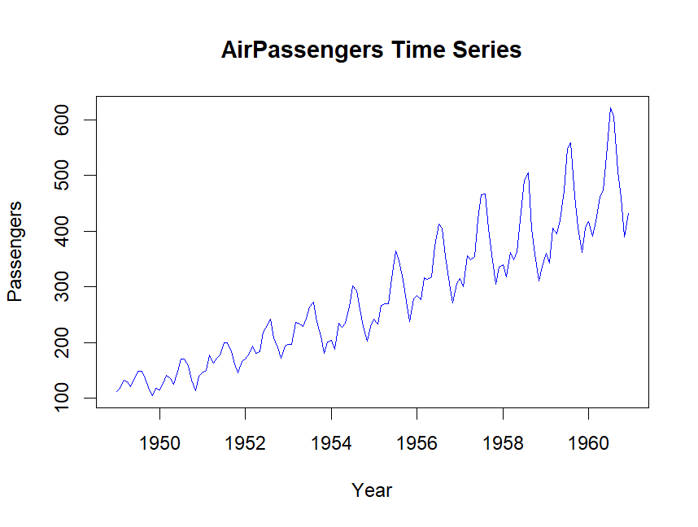

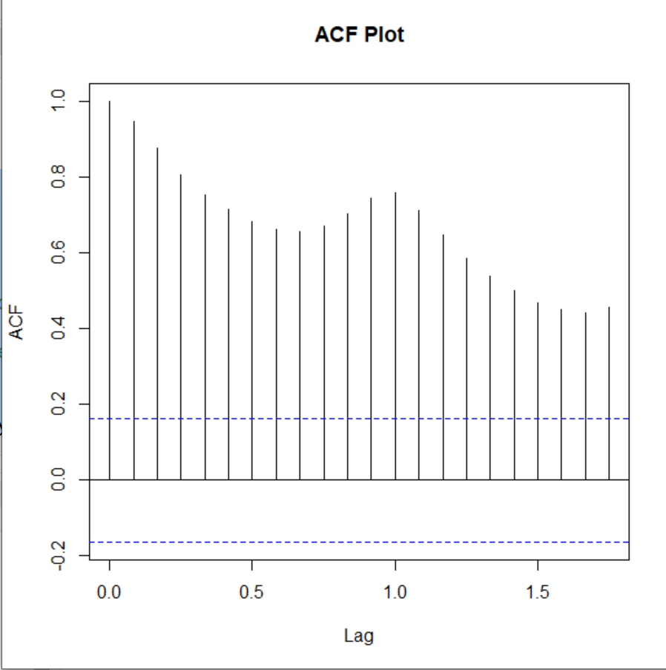

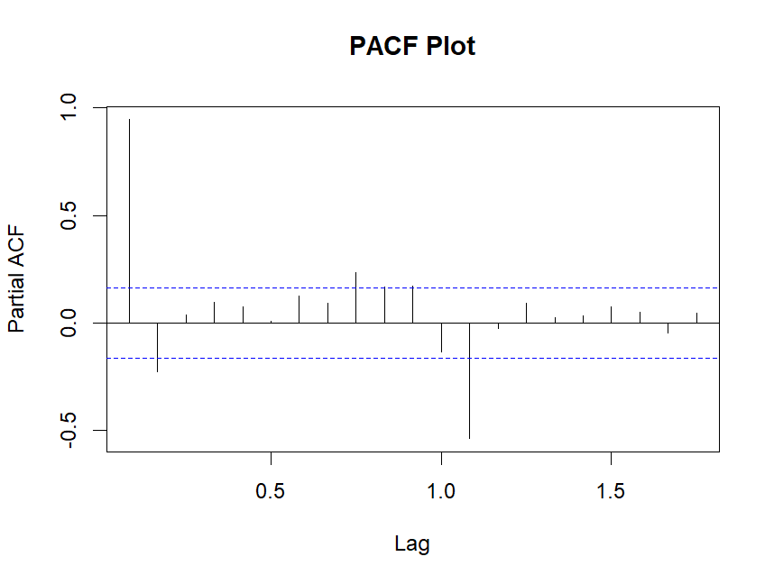

**EXPERIMENT 8 Date :**

**----------------------------------------------------------------------------------------------**

Write R program for Object segmentation using hierarchical based methods

**AIM: To implement hierarchical based methods**

**Description :** Hierarchical clustering is a technique used to group similar data points together based on their similarity creating a hierarchy or tree-like structure

A dendrogram is like a family tree for clusters. It shows how individual data points or

groups of data merge together.

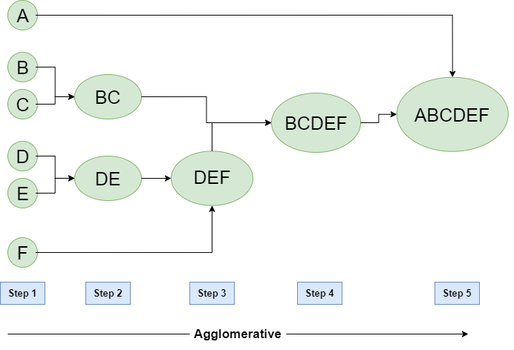

Types of Hierarchical Clustering

1. Agglomerative Clustering

2. Divisive clustering

**Workflow for Hierarchical Agglomerative clustering**

1. Start with individual points

2. Calculate distances between clusters

3. Merge the closest (smallest distance) clusters

4. Update distance matrix

5. Repeat steps 3 and 4 until only one cluster left.

6. Create a dendrogram

**Proogram :**

# Finding distance matrix

distance_mat <- dist(mtcars, method = 'euclidean')

distance_mat

# Fitting Hierarchical clustering Model

# to training dataset

set.seed(240) # Setting seed

Hierar_cl <- hclust(distance_mat, method = "average")

Hierar_cl

# Plotting dendrogram

plot(Hierar_cl)

# Choosing no. of clusters

# Cutting tree by height

abline(h = 110, col = "green")

# Cutting tree by no. of clusters

fit <- cutree(Hierar_cl, k = 3 )

fit

table(fit)

rect.hclust(Hierar_cl, k = 3, border = "green")

**OUTPUT:**

**Distance matrix:**

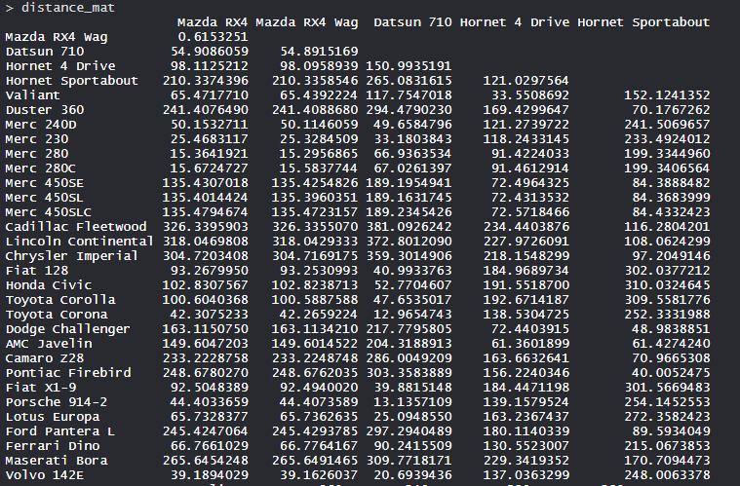

* The values are shown as per the distance matrix calculation with the method as euclidean.
* **Model Hierar_cl:**

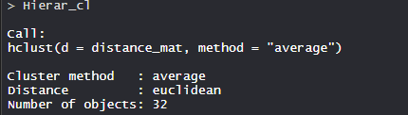

* In the model, the cluster method is average, distance is euclidean and no. of objects are 32.

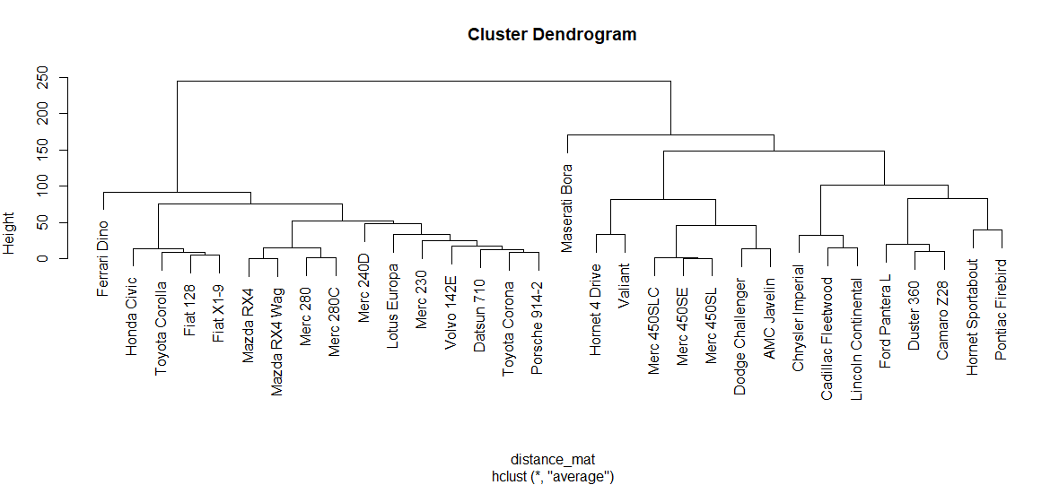

* So, Tree is cut where k = 3 and each category represents its number of clusters.

**EXPERIMENT 9 Date :**

**----------------------------------------------------------------------------------------------**

Write R program for Perform Visualization techniques (types of maps - Bar, Colum, Line, Scatter, 3D Cubes etc)

**AIM: To implement data Visualization techniques** (**tBar, Colum, Line, Scatter, 3D Cubes etc)**

### Consider the following airquality data set for visualization in R:

| **Ozone** | **Solar R.** | **Wind** | **Temp** | **Month** | **Day** |
| --- | --- | --- | --- | --- | --- |
| 41 | 190 | 7.4 | 67 | 5 | 1 |
| 36 | 118 | 8.0 | 72 | 5 | 2 |
| 12 | 149 | 12.6 | 74 | 5 | 3 |
| 18 | 313 | 11.5 | 62 | 5 | 4 |
| NA | NA | 14.3 | 56 | 5 | 5 |
| 28 | NA | 14.9 | 66 | 5 | 6 |

**a) AIM: To implement Bar Graph using R**

**PROGRAM:**

# Horizontal Bar Plot for

# Ozone concentration in air

barplot(airquality$Ozone,

main = 'Ozone Concenteration in air',

xlab = 'ozone levels', horiz = TRUE)

**OUTPUT:**

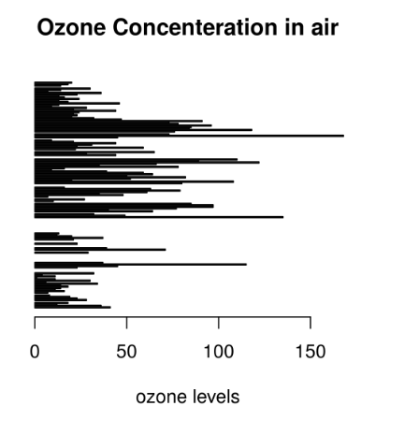

**b) AIM: To implement Histogram**

# Histogram for Maximum Daily Temperature

data(airquality)

hist(airquality$Temp, main ="La Guardia Airport's\

Maximum Temperature(Daily)",

xlab ="Temperature(Fahrenheit)",

xlim = c(50, 125), col ="yellow",

freq = TRUE)

**OUTPUT:**

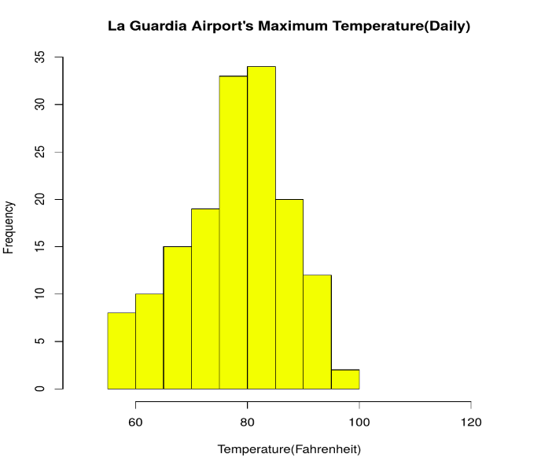

**c) AIM: To implement scatter graph**

**Program:**

# Scatter plot for Ozone Concentration per month

data(airquality)

plot(airquality$Ozone, airquality$Month,

main ="Scatterplot Example",

xlab ="Ozone Concentration in parts per billionn",

ylab =" Month of observation ", pch = 19)

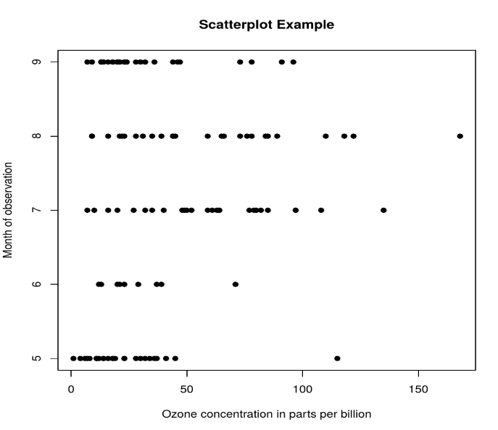

**d) AIM: To implement line graph**

**PROGRAM:**

# Create the data for the chart.

v <- c(17, 25, 38, 13, 41)

t <- c(22, 19, 36, 19, 23)

m <- c(25, 14, 16, 34, 29)

# Plot the bar chart.

plot(v, type = "o", col = "red",

xlab = "Month", ylab = "Article Written ",

main = "Article Written chart")

lines(t, type = "o", col = "blue")

lines(m, type = "o", col = "green")

**OUTPUT:**

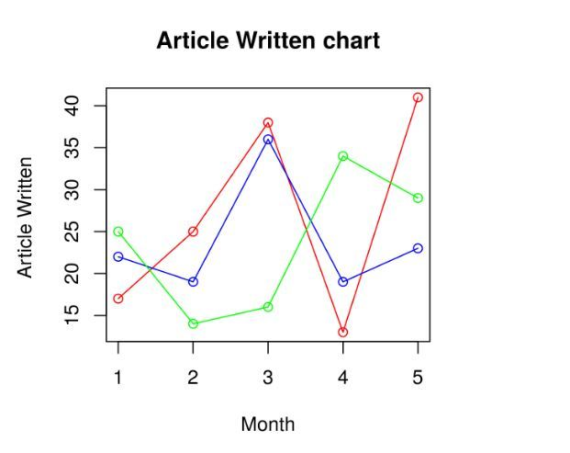

**e) AIM: To implement 3D plots graph**

**PROGRAM:**

# import and load rgl package

install.packages("rgl")

library(rgl)

# Generate some sample data

x <- seq(-5, 6, by = 0.1)

y <- seq(-5, 7, by = 0.1)

z <- outer(x, y, function(x, y) dnorm(sqrt(x^2 + y^2)))

# Create a 3D surface plot

persp3d(x, y, z, col = "blue")

# add animation

play3d(spin3d(axis = c(0, 0, 1)), duration = 10)



**Experiment 10 Date :**

**-------------------------------------------------------------------------------------------------------------------------------Write a R program to perform Descriptive analytics on healthcare data**

**AIM:** To implement Descriptive Analyticson healthcare data

**Description :** Descriptive analytics is the process of summarizing and interpreting historical data to understand what has happened in the past.

**Goals of Descriptive Analytics in Healthcare :**

* Understand patient demographics (e.g., age, gender distribution)
* Analyze clinical metrics like BMI(Body mass index), blood pressure, cholesterol
* Identify prevalence of conditions like diabetes, hypertension
* Spot trends over time (e.g., increasing obesity rates)
* Evaluate resource use (e.g., hospital admissions, medication use)

**Program :**

# Install required packages if not already installed

if (!require("summarytools")) install.packages("summarytools", dependencies = TRUE)

# Load the libraries

library(rgl)

library(dplyr)

library(summarytools)

# Try to load the data from CSV, if not found, create a sample dataset

file_path <- "health_data.csv"

if (!file.exists(file_path)) {

message("File not found. Creating sample dataset...")

set.seed(123)

health_data <- data.frame(

Age = sample(20:80, 100, replace = TRUE),

Gender = factor(sample(c("Male", "Female"), 100, replace = TRUE)),

BMI = round(runif(100, 18, 35), 1),

BloodPressure = sample(90:180, 100, replace = TRUE),

Cholesterol = sample(150:300, 100, replace = TRUE),

Diabetes = factor(sample(c("Yes", "No"), 100, replace = TRUE))

)

write.csv(health_data, file_path, row.names = FALSE)

} else {

health_data <- read.csv(file_path, stringsAsFactors = TRUE)

}

# View structure

str(health_data)

# Summary statistics for numeric variables

numeric_vars <- select(health_data, where(is.numeric))

summary(numeric_vars)

# Frequency tables for categorical variables

cat_vars <- select(health_data, where(is.factor))

lapply(cat_vars, table)

# Cross-tabulation: Gender vs Diabetes

print(table(health_data$Gender, health_data$Diabetes))

# Descriptive report using summarytools

print(dfSummary(health_data), method = "browser")

dev.new()

# 1. Plot Healthcare Attributes

plot(health_data, col ="magenta",)

dev.new()

# Plots

# 2. Age Distribution

hist(health_data$Age, main =" Age Distribution ",

xlab ="Age(in Yeaars)",

xlim = c(0, 125), col = "green",

freq = TRUE)

**Output :**

'data.frame': 100 obs. of 6 variables:

$ Age : int 50 34 70 33 22 61 69 73 62 56 ...

$ Gender : Factor w/ 2 levels "Female","Male": 1 1 2 2 2 1 1 1 1 2 ...

$ BMI : num 24.8 33 24.2 22.9 20.9 20.9 26.2 22.3 21.7 29.5 ...

$ BloodPressure: int 170 118 115 116 174 96 149 115 130 173 ...

$ Cholesterol : int 264 270 231 245 251 245 175 290 297 297 ...

$ Diabetes : Factor w/ 2 levels "No","Yes": 1 2 1 2 2 1 2 1 1 1 ...

> summary(numeric_vars)

Age BMI BloodPressure

Min. :22.00 Min. :18.10 Min. : 91.0

1st Qu.:34.00 1st Qu.:21.80 1st Qu.:115.8

Median :47.50 Median :26.05 Median :133.5

Mean :49.19 Mean :26.26 Mean :135.8

3rd Qu.:62.00 3rd Qu.:30.57 3rd Qu.:156.0

Max. :79.00 Max. :34.70 Max. :180.0

Cholesterol

Min. :152.0

1st Qu.:193.5

Median :243.0

Mean :230.8

3rd Qu.:268.0

Max. :297.0

$Gender

Female Male

55 45

$Diabetes

No Yes

52 48

> # Cross-tabulation: Gender vs Diabetes

No Yes

Female 32 23

Male 20 25

**Graph of Healthcare Attributes**

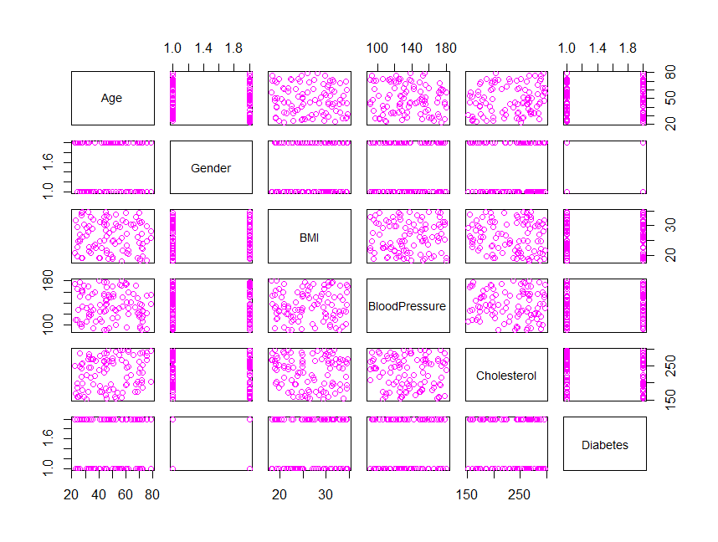

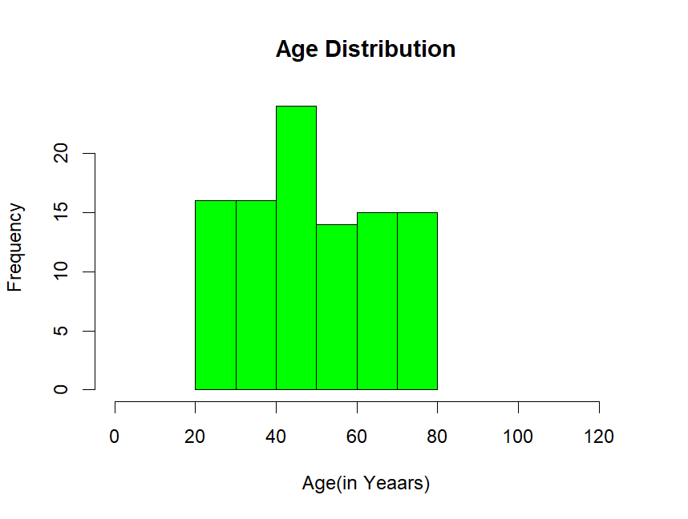

**EXPERIMENT 11 Date :**

**----------------------------------------------------------------------------------------------**

Write a R program to Perform Predictive analytics on Product Sales data methods

**AIM: To Perform Predictive analytics on Product Sales data**

**Description :** Predictive analytics uses historical data and statistical modeling to forecast future outcomes, determining the likelihood of specific events or trends

**Steps in Predictive analytics :**

**1. Focus on the Future:** Predictive analytics is not about understanding past events, but about anticipating future trends and outcomes.

**2. Data-Driven:** It relies heavily on data, both current and historical, to identify patterns and relationships that can be used to make predictions.

**3. Statistical Modeling:** Techniques like regression analysis, time series analysis, and machine learning algorithms are used to build models that can predict future outcomes.

**4. Decision Support:** The predictions generated by predictive analytics can be used to make informed decisions, such as optimizing business processes, identifying risks, or forecasting demand.

**Example:**

**Sales Forecasting**: Predicting future sales based on historical sales data, market trends, and promotional activities.

**Proogram :**

# Load the data

sales_data <- read.csv("product_sales.csv")

head(sales_data )

head(sales_data )

dev.new()

plot(sales_data, col="brown")

# Convert 'Season' to a factor

sales_data$Season <- as.factor(sales_data$Season)

# Split data into training (80%) and testing (20%)

set.seed(123)

sample_index <- sample(1:nrow(sales_data), 0.8 * nrow(sales_data))

train_data <- sales_data[sample_index, ]

test_data <- sales_data[-sample_index, ]

# Build a linear regression model

model <- lm(Sales ~ Price + Advertising + Season, data = train_data)

# Predict on test data

predicted_sales <- predict(model, newdata = test_data)

# Calculate RMSE

rmse <- sqrt(mean((test_data$Sales - predicted_sales)^2))

cat("Linear Regression RMSE:", rmse, "\n")

summary(model)

dev.new()

# -------------------------

# Plot: Actual vs Predicted

# -------------------------

plot(test_data$Sales, predicted_sales,

main = "Actual vs Predicted Sales",

xlab = "Actual Sales",

ylab = "Predicted Sales",

col = "blue",

pch = 19)

abline(a = 0, b = 1, col = "red", lwd = 2) # Reference line

**OUTPUT:**

TV Radio Newspaper Sales

1 86.3 30.0 23.9 17.11161

2 236.5 16.6 96.2 20.51756

3 122.7 24.4 60.1 16.92830

4 264.9 47.7 51.5 27.42344

5 282.1 24.1 40.3 22.14082

6 13.7 44.5 88.0 18.23741

**Sales Data**

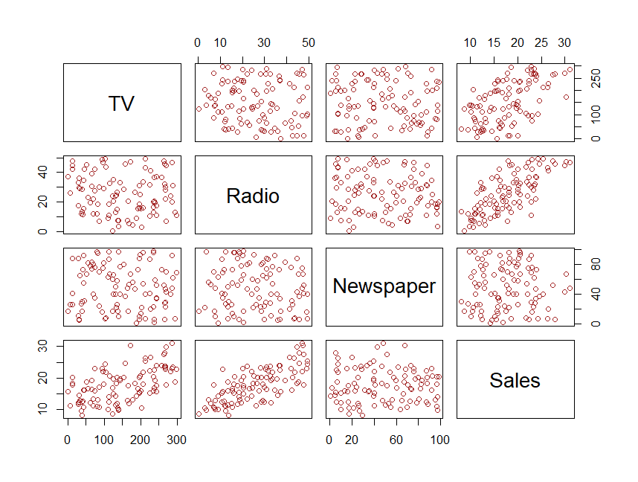

Linear Regression RMSE: 1.609265

summary(model)

Residuals:

Min 1Q Median 3Q Max

-2.4771 -0.9458 -0.1164 0.8441 4.2106

Coefficients:

Estimate Std. Error t value Pr(>|t|)

(Intercept) 2.316178 0.562091 4.121 9.54e-05 ***

TV 0.039634 0.002340 16.940 < 2e-16 ***

Radio 0.328001 0.012074 27.166 < 2e-16 ***

Newspaper 0.021045 0.005086 4.138 8.98e-05 ***

---

Residual standard error: 1.384 on 76 degrees of freedom

Multiple R-squared: 0.9189, Adjusted R-squared: 0.9157

F-statistic: 287 on 3 and 76 DF, p-value: < 2.2e-16

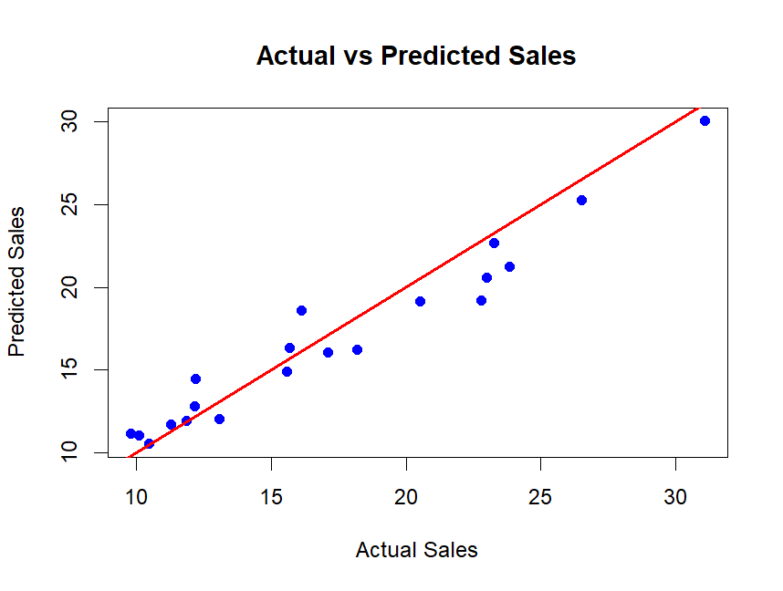

**EXPERIMENT 12 Date :**

**----------------------------------------------------------------------------------------------**

Write a R program to Apply Predictive analytics for Weather forecasting.

**AIM: To Apply Predictive analytics for Weather forecasting.**

**Description :** Predictive analytics uses historical data and statistical modeling to forecast future outcomes, determining the likelihood of specific events or trends

**Weather forecasting** : It involves a sequence of steps

**Step 1 :**  **Data Collection :** Data collects from Ground stations like Temperature,

humidity, wind speed, pressure, rainfall, etc.

**Step 2 : Data Preprocessing & Quality Control :** Raw data is often noisy or

incomplete, so: Missing values are estimated or removed.

Outliers are detected and handled.

**Step 3 : Feature Engineering :** To improve model performance:

Create derived variables (e.g., wind chill, heat index).

Convert date/time into cyclical features.

Convert categorical data (e.g., weather types) into numeric encodings.

**Step 4 : . Model Building :** Use Statistical or Machine Learning Models:

Use historical data to learn patterns.

Common methods: Linear regression for temperature

SVM / Decision Trees for classification (e.g., rain prediction)

Time series models like ARIMA, LSTM

**Step 5 : . Model Evaluation :**

Models are tested using Training/testing split or cross-validation

Metrics like: RMSE / MAE for temperature

Accuracy, Precision, Recall for rain or storm predictions

**Step 6 : . Forecasting :** Forecasts are generated for:

Short-term (1–3 days): Highly accurate

Medium-term (4–7 days): Good reliability

Long-term (>7 days): Increasing uncertainty

**Forecasts may include:** Temperature, Rainfall likelihood, Wind speed and

direction, Storm alerts

**Proogram :**

# Load libraries

library(lubridate)

library(e1071)

# Load data

weather_data <- read.csv("weather_data.csv", stringsAsFactors = FALSE)

# Initial plot

dev.new()

plot(weather_data, main = "Weather Dataset", col = "green")

# Parse date and extract features

weather_data$date <- ymd(weather_data$date)

weather_data$day_of_year <- yday(weather_data$date)

weather_data$month <- month(weather_data$date)

weather_data$weekday <- wday(weather_data$date)

# Create rain label if applicable

if (!"rain_label" %in% names(weather_data) && "rain" %in% names(weather_data)) {

weather_data$rain_label <- as.factor(ifelse(weather_data$rain > 0, "Yes", "No"))

}

# Split into training and testing sets

set.seed(123)

sample_size <- floor(0.8 * nrow(weather_data))

train_indices <- sample(seq_len(nrow(weather_data)), size = sample_size)

train_data <- weather_data[train_indices, ]

test_data <- weather_data[-train_indices, ]

# Train temperature model

model_temp <- lm(temperature ~ humidity + pressure + day_of_year + month + weekday, data = train_data)

train_data$predicted_temp <- predict(model_temp, newdata = train_data)

# Train SVM model for rain prediction if applicable

rain_model_exists <- FALSE

if ("rain_label" %in% names(weather_data)) {

model_rain_svm <- svm(rain_label ~ humidity + predicted_temp + pressure + day_of_year + month + weekday,

data = train_data, type = "C-classification", kernel = "radial")

rain_model_exists <- TRUE

}

# Evaluate temperature model

predictions <- predict(model_temp, newdata = test_data)

rmse <- sqrt(mean((test_data$temperature - predictions)^2, na.rm = TRUE))

cat("Root Mean Squared Error (RMSE):", round(rmse, 2), "\n")

# Summary

summary(model_temp)

if (rain_model_exists) print(summary(model_rain_svm))

# Plot actual vs predicted temperature

dev.new()

plot(test_data$temperature, predictions,

col = "blue", pch = 16,

main = "Actual vs Predicted Temperature",

xlab = "Actual Temperature", ylab = "Predicted Temperature")

abline(0, 1, col = "red", lwd = 2)

# --- Future Forecasting ---

# Generate next 7 days

future_dates <- seq(max(weather_data$date) + 1, by = "day", length.out = 7)

# Create future data frame

future_data <- data.frame(

date = future_dates,

day_of_year = yday(future_dates),

month = month(future_dates),

weekday = wday(future_dates),

humidity = mean(train_data$humidity, na.rm = TRUE),

pressure = mean(train_data$pressure, na.rm = TRUE)

)

# Ensure factor compatibility

if (is.factor(train_data$weekday)) {

future_data$weekday <- factor(future_data$weekday, levels = levels(train_data$weekday))

}

# Predict temperature

future_data$predicted_temp <- predict(model_temp, newdata = future_data)

future_data$predicted_temperature <- round(future_data$predicted_temp, 2)

# Predict rain if model exists

if (rain_model_exists) {

raw_preds <- predict(model_rain_svm, newdata = future_data)

raw_preds <- as.character(raw_preds)

future_data$rain_prediction <- ifelse(raw_preds == "Yes", "RAIN=YES", "RAIN=NO")

} else {

future_data$rain_prediction <- rep("RAIN=NA", nrow(future_data))

}

# Display forecast

cat("\nNext 7 Days Forecast:\n")

print(future_data[, c("date", "predicted_temperature", "rain_prediction")])

# Plot forecast

dev.new()

plot(future_data$date, future_data$predicted_temperature, type = "o",

col = "red", lwd = 4, pch = 5,

main = "7-Day Forecast: Temperature & Rain",

xlab = "Date", ylab = "Temperature (°C)",

ylim = range(future_data$predicted_temperature, na.rm = TRUE) + c(-1, 2))

grid()

# Add temperature labels

text(future_data$date, future_data$predicted_temperature + 0.4,

labels = future_data$predicted_temperature,

col = "red", cex = 1)

# Add rain prediction labels with color mapping

rain_colors <- ifelse(future_data$rain_prediction == "RAIN=YES", "blue",

ifelse(future_data$rain_prediction == "RAIN=NO", "magenta", "yellow"))

text(future_data$date, future_data$predicted_temperature + 1,

labels = future_data$rain_prediction,

col = rain_colors, font = 2, cex = 0.9)

# Add legend

legend("topright", legend = c("Temperature (°C)", "RAIN=YES", "RAIN=NO", "RAIN=NA"),

col = c("red", "blue", "magenta", "yellow"),

pch = 16, bty = "n")

# --- Bonus: Plot raw temperature over time with rain indicators ---

dev.new()

plot(weather_data$date, weather_data$temperature, type = "o",

col = "magenta", lwd = 2, pch = 16,

main = "Temperature Over Time",

xlab = "Date", ylab = "Temperature (°C)")

points(weather_data$date[weather_data$rain > 0],

weather_data$temperature[weather_data$rain > 0],

col = "blue", pch = 17, cex = 1.2)

legend("topright",

legend = c("Temperature", "Rainy Days"),

col = c("magenta", "blue"),

pch = c(16, 17),

bty = "n")

**OUTPUT:**

> head(weather_data )

date temperature humidity pressure rain

1 2024-01-01 32.01821 73.83717 1022.128 0

2 2024-01-02 32.79764 45.20104 1012.928 1

3 2024-01-03 10.01488 45.15971 1021.298 1

4 2024-01-04 29.06567 57.22615 1011.070 1

5 2024-01-05 22.46109 95.97190 1003.947 0

6 2024-01-06 18.16836 97.38256 1011.058 0

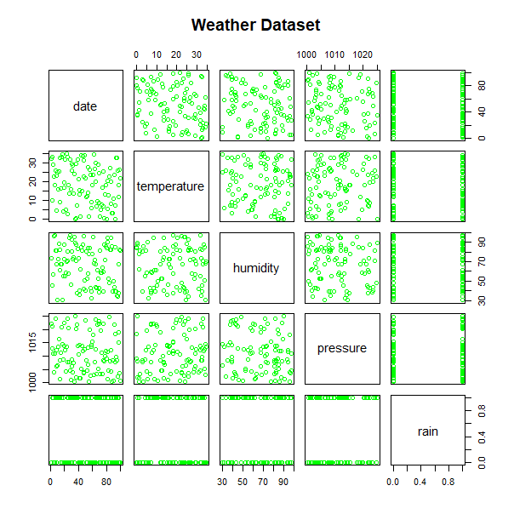

Root Mean Squared Error (RMSE): 10.86

> #Summary of Models

> summary(model_temp)

Call:

lm(formula = temperature ~ humidity + pressure + day_of_year +

month + weekday, data = train_data)

Residuals:

Min 1Q Median 3Q Max

-16.4739 -9.5256 0.7116 8.9975 16.6716

Coefficients:

Estimate Std. Error t value Pr(>|t|)

(Intercept) -35.73927 174.87503 -0.204 0.839

humidity -0.02731 0.06225 -0.439 0.662

pressure 0.05533 0.17191 0.322 0.748

day_of_year -0.17027 0.13703 -1.243 0.218

month 3.19049 3.97729 0.802 0.425

weekday 0.36879 0.58653 0.629 0.531

Residual standard error: 10.41 on 74 degrees of freedom

Multiple R-squared: 0.05175, Adjusted R-squared: -0.01232

F-statistic: 0.8077 on 5 and 74 DF, p-value: 0.5479

> summary(model_rain_svm)

Call:

svm(formula = rain_label ~ humidity + predicted_temp +

pressure + day_of_year + month + weekday,

data = train_data, type = "C-classification",

kernel = "radial")

Parameters:

SVM-Type: C-classification

SVM-Kernel: radial

cost: 1

Number of Support Vectors: 72

( 38 34 )

Number of Classes: 2

Levels:

No Yes

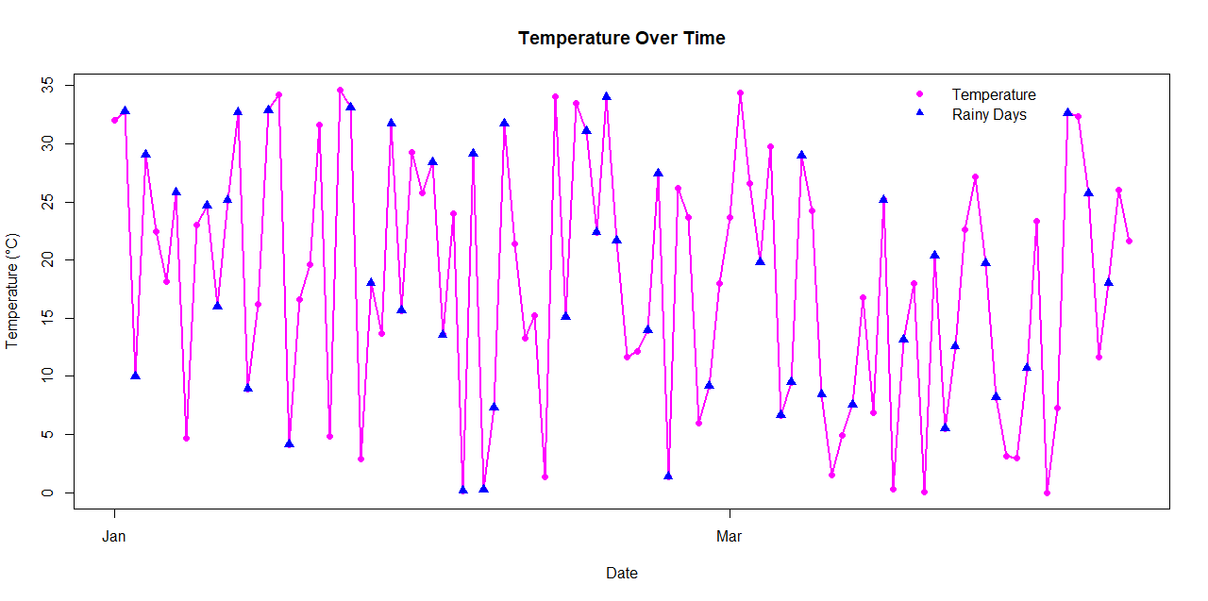

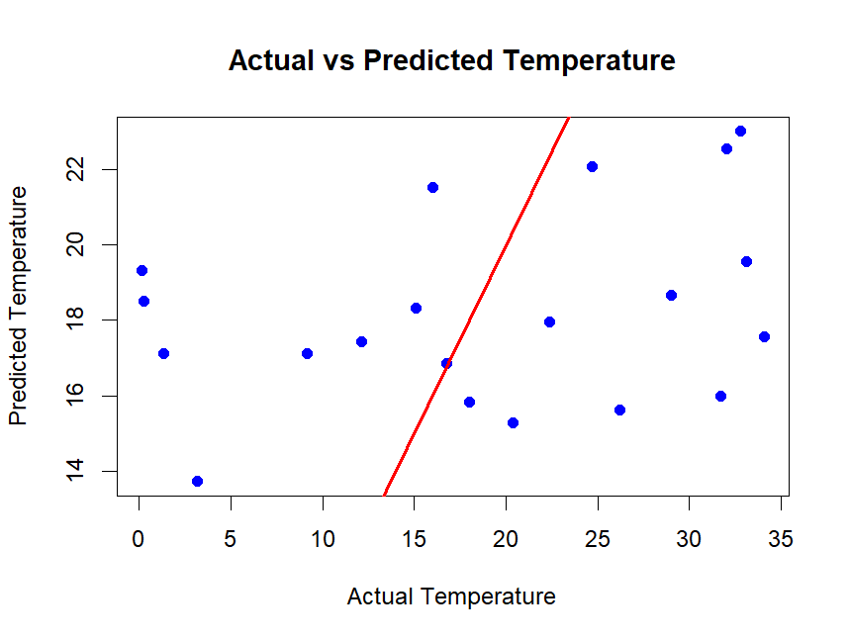

Next 7 Days Forecast:

date predicted_temperature rain_prediction

1 2024-04-10 15.47 RAIN=NO

2 2024-04-11 15.67 RAIN=NO

3 2024-04-12 15.87 RAIN=NO

4 2024-04-13 16.07 RAIN=NO

5 2024-04-14 13.68 RAIN=NO

6 2024-04-15 13.88 RAIN=NO

7 2024-04-16 14.08 RAIN=NO

